# Project Design Phase-I Solution Architecture

|  |  |
| --- | --- |
| Date | 16 October 2022 |
| Team ID | PNT2022TMID48925 |
| Project Name | Project – Deep Learning Fundus Image Analysis  for Early Detection of Diabetic Retinopathy |
| Maximum Marks | 4 Marks |

# Solution Architecture Diagram:

NDR

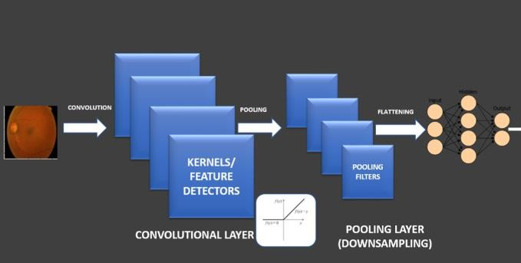

DR